1. About moments when wondering whether it is true

Walk me through a recent experience when you watch/listen to news and wonder about whether it is true?

* Under what scenario
* What made you wonder about the authenticity
* How did you check it out?
* What frustrated you in the process?

Under what situations would you wonder about whether it is true or not

The scenario we set for this project might be:

when you listening to a podcast or watching TV, you hear a piece of news sounds like wired. Then you ask Alexa “XXX” to check the new you heard. And Alexa answered: “XXX”. And then you ask a following question ‘”. And Alexa gives you a more specific answer.

2. About current solutions

Take a look at some automated fact-checking products and give it some thoughts

* Facebook- flags in news feed

Alerts when you share a disputed link, report fake news

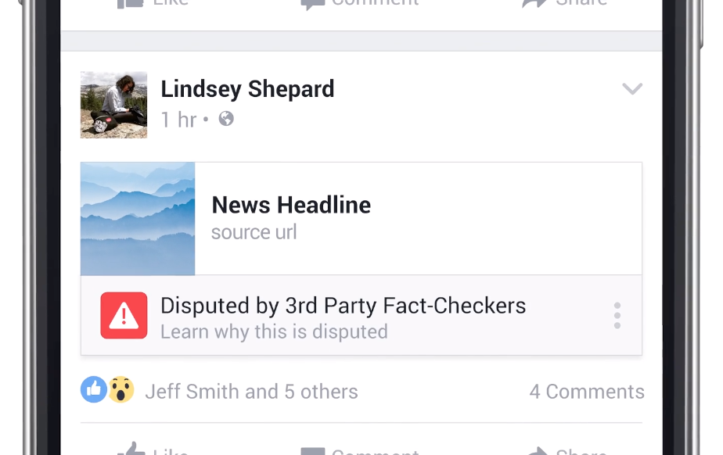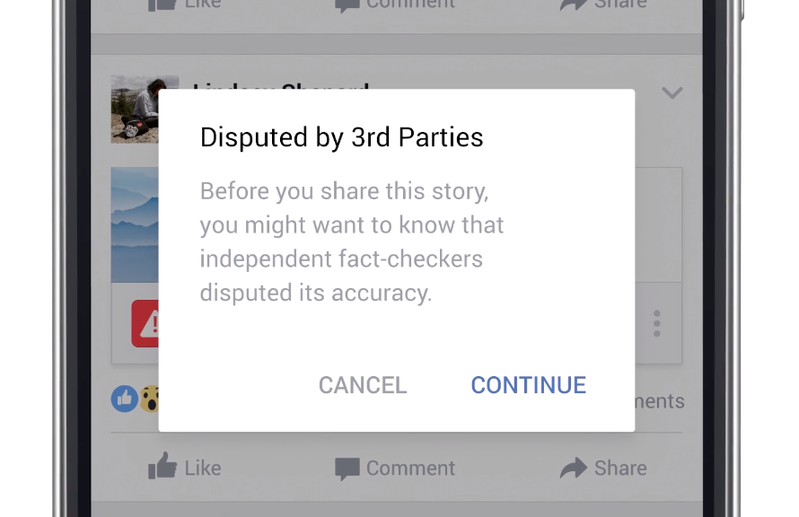

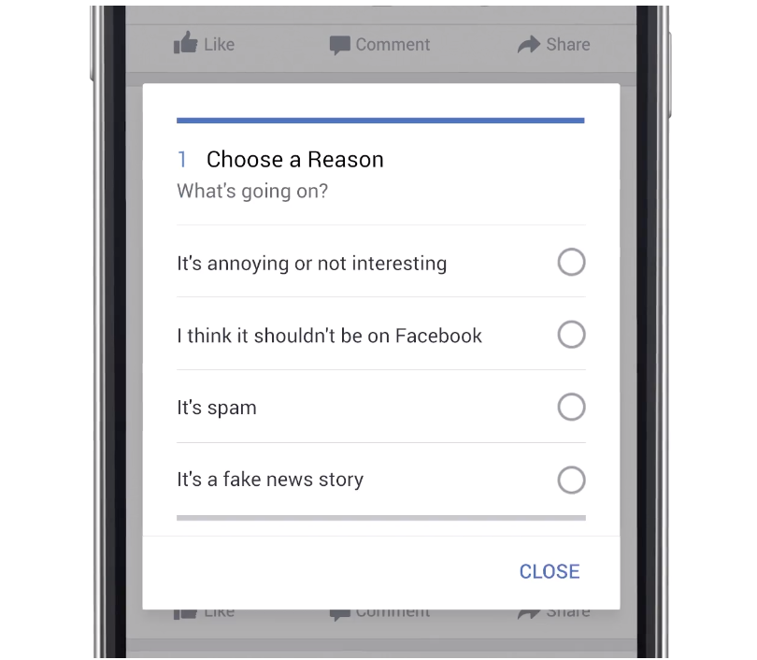

* Yale

3.News test

Near half americans are living paycheck to paycheck

Synthesis:

Consume audio of news usually happens passively.

The user cares about self-related policies. Even after cross checking different sources, the user will turn back to official website when she needs to take actions related to the policy.

## Interview - Hua

Passive listen to the news when listening to the radio on the car

Actively reading news from social media

Care about the news related to myself, for example, student visa

Some news are not fake, but they are talking about the projection, something that will happen in years, so you need to take care

When wondering about the authenticity of the news:

First, have direct judgement based on common sense,

Would read the comments when not having an immediate judgements and then judge the comments based on common sense

Would trust the news if it cited the source even if she usually doesn’t check the source

## 

## Interview - Haein

Nationality: American, race: Korean

* Usually read news articles on yahoo, and news feeds(articles/images/video) on facebook

Follow news on other channels for really important news

Care about healthcare and immigrant news

Consume politics news when it comes to really important things

Watch talk shows (eg. Trevor Noah)

* First impression based on the headline
  + eg.The former sportscaster accusing NBA coach Luke Walton of sexual assault says she was scared to tell her story
    - Skeptical because sexual sexual assault is a very sensitive issue, that could be false accusation
    - 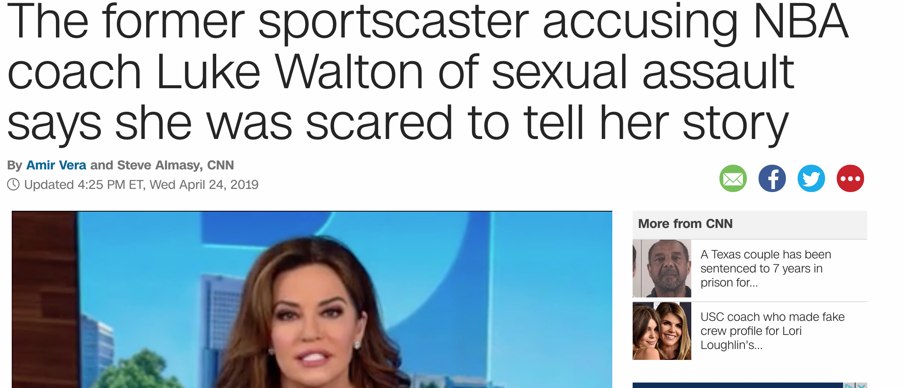
  + Eg. Joe Biden to announce his 2020 presidential bid on Thursday
    - Convinced because it is a positive thing and neutral statement.
    - It is low risk because Thursday will come soon.
  + Eg. Trump White House official on border: 'We could be in a whole world of hurt' - CNNPolitics
    - Skeptical to everything around Trump
* Second impression based on where the source is
  + Eg. Joe Biden to announce his 2020 presidential bid on Thursday
* The detailed information - how they frame it
  + Eg.Rite Aid raises tobacco buying age to 21, following Walgreens’ lead
    - “A dozen states have already raised the minimum buying age and a handful of others are exploring similar action.
    - Surprised by the legal
    - Skepical because the statement doesn’t show specific states. “Do You know what you are saying”
    - <https://www.cnbc.com/2019/04/23/rite-aid-raises-tobacco-buying-age-to-21-following-walgreens-lead.html>

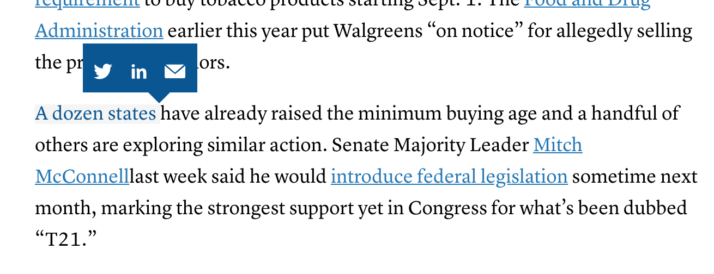

* + Eg"It's something that I'm sure we'll be looking into and studying," Kevin Hassett, the chairman of the Council of Economic Advisers, told reporters Monday.
    - Skeptical about whether they will do
* Reflect on what the message the news is trying to convey

Eg. redricks. Highschool

I don’t like Trump. But it is too good to be true. So bizarre to be true

Question about the message

* Skeptical about the truth doesn’t mean he wants to check it, not related to him that much

INSIGHT:

What makes user skeptical: source, topic, framing, risk

## Interview - Simon

Tricky language

* Red-flag phrases
  + Phrases like “it is understood” are a sign someone is letting you fill in the gaps yourself. Even an anonymous source or the dreaded “sources said” is better than a source that is simply implied.
  + This could be anything from “someone told me that” to “there are rumours that” or even “I think that probably it was”.
  + 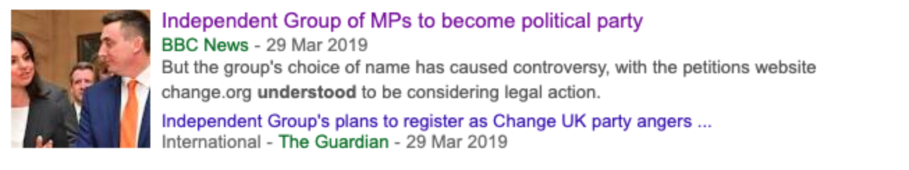
  + 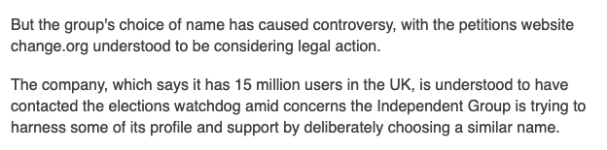
* evaluate the facts and the context
  + Is the story an interpretation of the facts? Can they be interpreted any other way?
  + With extreme claims – could any of this have been taken out of context, fabricate, or otherwise manipulate
  + It’s a joke to say a friend of friend told you something but reporters quote “someone familiar with” … whatever, all the time.
  + 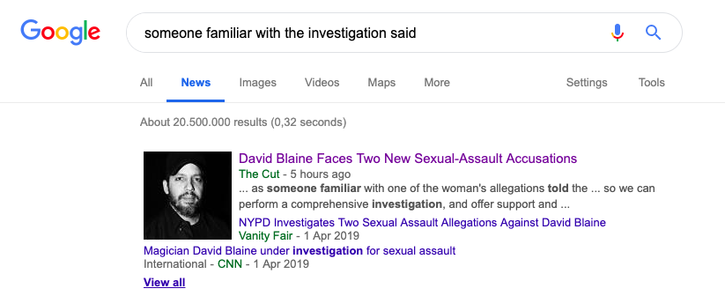
* Media Literacy
  + Who is the creator?
    - the person behind the presentation of the material
    - the person’s expertise
  + What is the message
    - Can I find this same news in multiple places
    - What viewpoint is being expressed and what is being left out?
    - What is the format of the message? Look at visual elements and text elements.
  + Why was this created

## Interview - David

Financial / marketing news

Trust the

Take the subscribe , just follow

Podcast

Frame the data in different ways (cite sources

Not feasible to check the numbers yourself

Open at certain number days

Prejection ( crossed check

What other resources

Multiple

Wsj marketer

source :SIX

So public transparent

Histotical example

reading : exonomic

Truth:

Trumpl

## Secondary research: politifact

"We’re in a situation right now where 80% of the country is living paycheck to paycheck."

— Marie Newman on Wednesday, April 24th, 2019 in a radio interview

Half ture:

* Missing context
  + include the nearly 40% of people who report only "sometimes" living paycheck to paycheck in the grand total.
* Other resources
  + The claim reflects one single survey, but it appears to be an outlier among similar polls.<http://press.careerbuilder.com/2017-08-24-Living-Paycheck-to-Paycheck-is-a-Way-of-Life-for-Majority-of-U-S-Workers-According-to-New-CareerBuilder-Survey>
  + The statement is partially accurate but leaves out important details or takes things out of context.

“Half the country today has either diabetes or prediabetes.A diabetic costs 2.3 times as much as every other patient. That is going to sink the health care system.”

Almost ture:

The American Diabetes Association told us it would be more accurate to say that nearly half of all adults in the United States have either diabetes or prediabetes.

The measure of people with prediabetes is a bit different: only measuring people 18 years old and older.

"Most of home care is paid by government programs."

long-term unskilled care hasn’t been accountable